**No Confidence: A Quick Look at Pfizer’s Phase 3 Covid Vaccine Trial for Children**

James M. Eli on 6/20/2022

FDA advisors just voted 21-0 to authorize use of Covid vaccines for children 6 months old to 5 years old[1].

Germany, France, Denmark, Norway, Sweden, and Finland all suspended Moderna for people under 30 due to safety concerns. But in the U.S., we’ll now be giving this product to infants.

Stating that much gets one banned on Twitter. Every statement a fact. TRUTH.

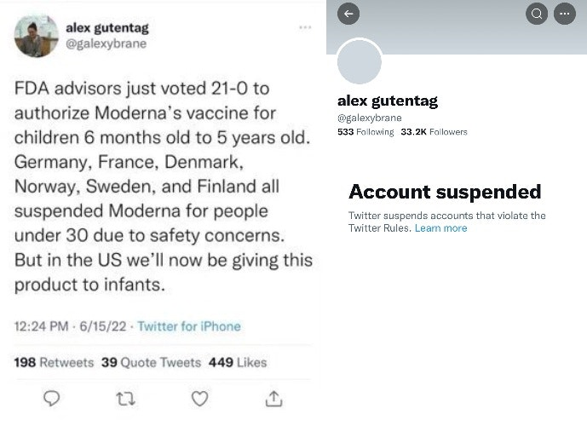

It's beyond idiotic. The FDA advisors voted unanimously to authorize their emergency use.[2]

Try to spot the difference in Covid cases between the vaccine and placebo groups in the Pfizer supplied graph below. The lines don’t even start to split until 140 days (almost 5 months) has passed, and then both groups still climb at similar rates.

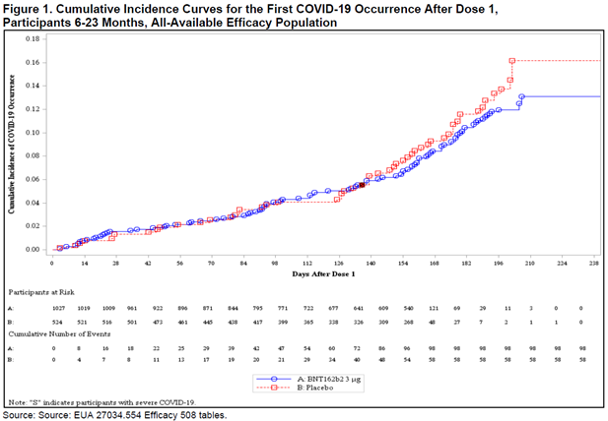

Here is a look at the vaccine efficacy throughout the inoculation process:

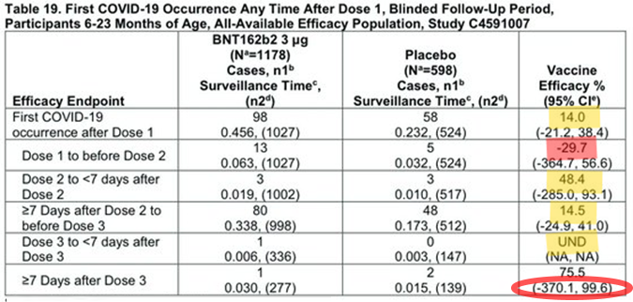

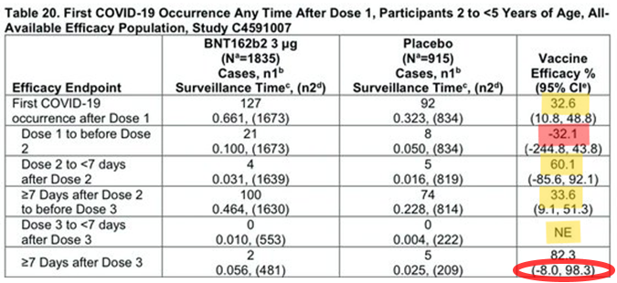

Between the first and second doses, the vaccine has a *negative* VE, meaning it increases one's chance of getting Covid (by 30%). Then our children need to wait until 7 days after the booster shot (about 6 months from the start of the process) when the vaccine finally reaches the claimed 75-82% effectiveness. This claimed effectiveness is based upon a difference between the vaccine and placebo groups of 3 total cases in the study! Summing all of this for both sets of kids and normalizing for person years of exposure nets a 23.9% VE from day one.

To say the vaccine has a VE of 75-82% requires one to ignore 97% of the Covid cases that occurred during the trial. Recommending this inoculation is akin to saying in the middle of a hurricane storm, “you’ll be safer if you leave your house and walk through the hurricane.”

By the way, the trial only followed the children for 1-month after the booster shot. Why wouldn’t they test longer? Was Pfizer too afraid to learn how quickly the protection would wane and how far negative the effectiveness would then progress?

Furthermore, look at the confidence intervals in the trial results (I’ve circled the ones for the endpoint efficacy in red). They’re off-the-chart crazy! For those unaware, a confidence level says, “we believe with 95% confidence, the actual vaccine effectiveness falls somewhere in this range.” Nearly 400% negative efficacy on the lower end(s). This means that the children could have an almost 4-times greater chance of getting sick with Covid because they took the vaccine!

There is NO statistical significance in this study, and it completely lacks certainty in their results. This is dart board stuff. We’re way past incompetence and accidents here. This is criminal negligence.

All of this comes from the FDA VRBPAC 6/14-15/2022 Meeting Briefing Document[3].

But wait, there’s more.

Foremost is the trial started with 4526 participants, of which approximately 3000 didn’t make it to the end. Two-thirds didn’t make it! Why? All they said about the ones excluded was, “participants may have been excluded for more than one reason.”

From Dose 1 through the data cutoff, 2 placebo recipients and 6 vaccine recipients met the criteria for severe COVID-19. Only one child was hospitalized for severe COVID-19 (fever and seizure) and that child was vaccinated. So, the vaccine doesn’t prevent Covid, AND it doesn’t prevent severe outcomes either.

Study withdrawals due to adverse events in participants were reported in 6 BNT162b2 recipients and 1 placebo recipient.

The uncertainties associated with benefits of the vaccine are legion! Here they are in Pfizer’s own words as presented to the FDA:

1. Duration of vaccine effectiveness, the blinded, placebo-controlled evaluation period for descriptive efficacy analyses was limited, and waning of protection following a primary series has been observed in older age groups.
2. Need for a booster dose based on experience with adults, it is likely that a booster dose will be needed in addition to the three-dose primary series to increase robustness, breadth, and duration of protection.
3. Effectiveness in certain populations at high risk of severe COVID-19, including immunocompromised individuals.
4. Benefits in individuals previously infected with SARS-CoV-2: descriptive post-Dose 3 efficacy analyses do not include cases in previously infected participants. However, observational data with other COVID-19 vaccines have demonstrated an added benefit of vaccination to protection conferred by natural immunity.53 Additionally, for individuals previously infected with the Omicron variant of SARS-CoV-2, a vaccine based on the ancestral strain S protein could provide a greater breadth of protection against SARS-CoV-2 variants.
5. Effectiveness in preventing post-acute sequelae of COVID-19: available data are not conclusive on the effectiveness of COVID-19 vaccines currently in use against long-term sequelae of COVID-19 among individuals who are infected despite vaccination. Additional evaluation is needed to assess the effect of this vaccine in preventing long-term effects of COVID-19, including data from clinical trials and from the vaccine's use post-authorization.
6. Future vaccine effectiveness as influenced by characteristics of the pandemic, including emergence of new variants: the continued evolution of the pandemic, including changes in the virus infectivity, antigenically significant mutations to the S protein, and changes in practice of nonpharmacologic interventions to mitigate against transmission, will likely influence vaccine effectiveness over time. Continued evaluation of vaccine effectiveness following issuance of an EUA and/or licensure will be critical.
7. Vaccine effectiveness against asymptomatic infection and transmission of SARS-CoV-2: Available data for COVID-19 vaccines currently in use has demonstrated that effectiveness against asymptomatic infection is lower and less durable than effectiveness against symptomatic COVID-19. Available data also do not indicate high-level or durable effectiveness against transmission of SARS-CoV-2 from vaccinated individuals with breakthrough infections.

“The FDA bent its standards to an unusual degree and brushed aside troubling evidence that warrants more investigation.[4]”

There is a giant foolish misconception spreading throughout the government and media that the this newly approved Pfizer (and Moderna) shot for children is a new shot. Sadly, this is not true. The shots being distributed were designed for the Wuhan strain of the coronavirus. They were engineered for a Covid strain that has not been identified in circulation for over two years. This is like taking a flu shot from several years ago!

Adding to the incredulity, during the VRBPAC meeting, the CDC showcased highly misleading data about the risk of Covid to children. The agency featured a pre-print study[5] claiming to show that Covid was a leading cause of death for children in the United States. However, observers quickly pointed out major flaws in the data which rendered it misleading and deceitful.

The paper ranks Covid as a top cause of death by confusingly mixing cumulative Covid deaths alongside annual rates for other causes. A further issue with the CDC data presentation is the conflation of deaths caused directly by Covid versus those for which Covid was just a “contributing” factor. The authors state “we only consider Covid-19 as an underlying (and not contributing) cause of death,” but that is false. The paper cites data from the National Center for Health Statistics (NCHS), which tabulates Covid deaths by including any death certificate on which Covid is mentioned, not just cases where it was the primary reason for death.

And how does the U.S. stand with the rest of the world on this? As of a few weeks ago there were only 7 countries where kids under 5 were given Covid injections, though the WHO now claims that number is 12. The seven countries are: Argentina, Bahrain, Chile, China, Cuba, UAE, Venezuela (the territory of Hong Kong, which uses Chinese-made shots, is sometimes listed as the eighth country).

However, Venezuela and Cuba are the only countries that allow for Covid shots between the ages of two and three. The rest of the countries only go as young as three. None of the nations are using mRNA. Five out of seven are using Chinese manufactured inactivated vaccines. Cuba and Venezuela are using the Cuban homebrew shot. None of these countries are allowing Covid shots for those between the ages of 6 months and two years, which means that the United States has become the only country in the world to allow for experimental Covid injections shots for babies and 2-year-old toddlers.

1. https://www.cdc.gov/media/releases/2022/s0618-children-vaccine.html
2. The Emergency Use Authorization authority allows the FDA via the Federal Food, Drug, and Cosmetic Act to authorize *unapproved medical products* or unapproved uses of approved medical products to be used in an *emergency* to diagnose, treat, or prevent *serious or* *life-threatening diseases* or conditions caused by chemical, biological, radiological, and nuclear threat agents when certain criteria are met, including there are no adequate, approved, and available alternatives. The 1938 Food, Drug, and Cosmetic Act is the law that requires companies to test their products for safety before selling them. https://www.fda.gov/emergency-preparedness-and-response/mcm-legal-regulatory-and-policy-framework/emergency-use-authorization
3. https://www.fda.gov/media/159195/download
4. https://www.wsj.com/articles/why-the-rush-for-toddler-vaccines-covid-pandemic-children-fda-pfizer-moderna-medicine-evidence-11656951993
5. https://www.medrxiv.org/content/10.1101/2022.05.23.22275458v1